MAIN PAGE

SIDING & SOFFIT
Industrial / Residential / Commercial
Enhance the aesthetic and functional appeal of your industrial, residential, or commercial property with our high-quality siding solutions. At Cladcan, we offer a wide range of siding materials designed to meet diverse architectural needs and performance requirements. Choose from an impressive selection of solid colors and realistic wood-look finishes to achieve the perfect visual effect for your project. Our products ensure durability, energy efficiency, and exceptional visual appeal, making them ideal for any building project.
Find the ideal match for your project with our impressive array of offerings!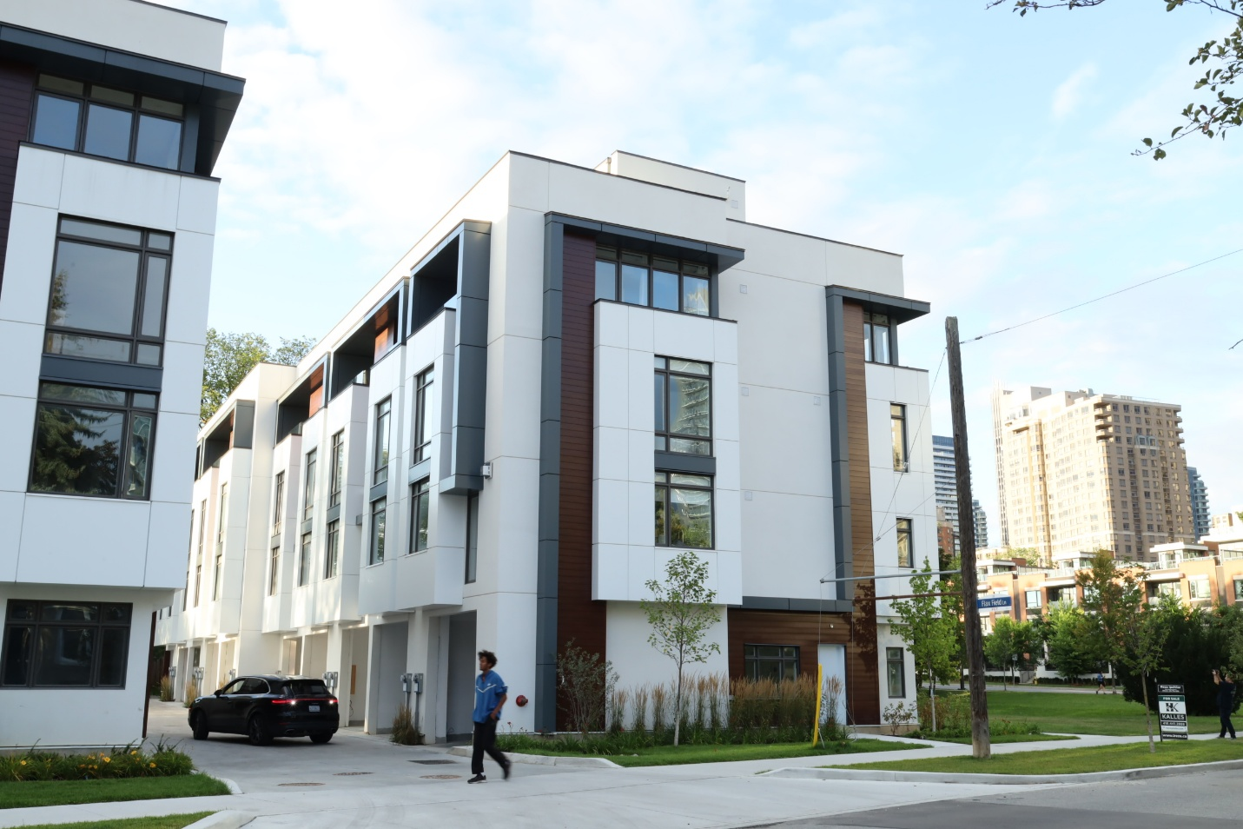

SIDING & SOFFIT MENU ICON (PREVIEW)

Aluminum Siding & Soffit
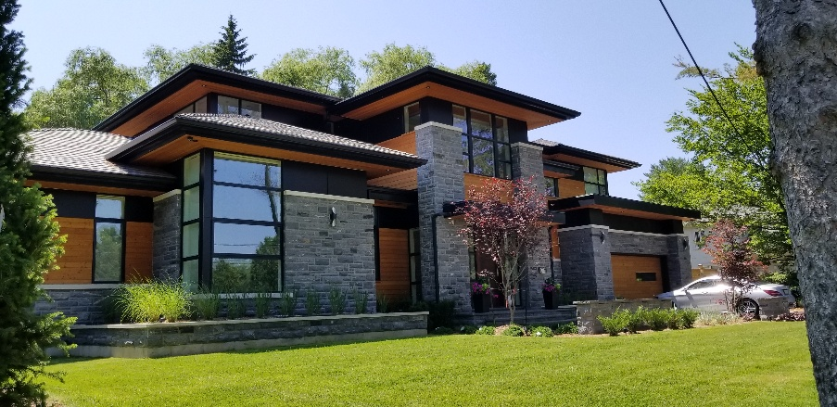
Our premium aluminum siding & soffit solutions are meticulously crafted to elevate both the aesthetic allure and structural fortitude of your project, seamlessly marrying elegance with practicality. (Learn More- Expand)
Expanded …Our aluminum siding & soffit boasts an extensive palette of colors and textures, providing robust protection against the elements while enhancing your build’s visual charm. Delve into our Aluminum panel choices to uncover how our cutting-edge siding options that can redefine your living & working spaces with enduring sophistication and effortless upkeep.
Curious about the advantages of aluminum siding? Visit our blog to explore the compelling reasons why this choice stands out for homeowners seeking durability and style.
Speak with an Expert
Get personalized advice and expert guidance to achieve your project goals with confidence.

2- CEDAR RENDITION MENU ICON (PREVIEW)

Cedar Renditions Cost-effective Siding and Soffit
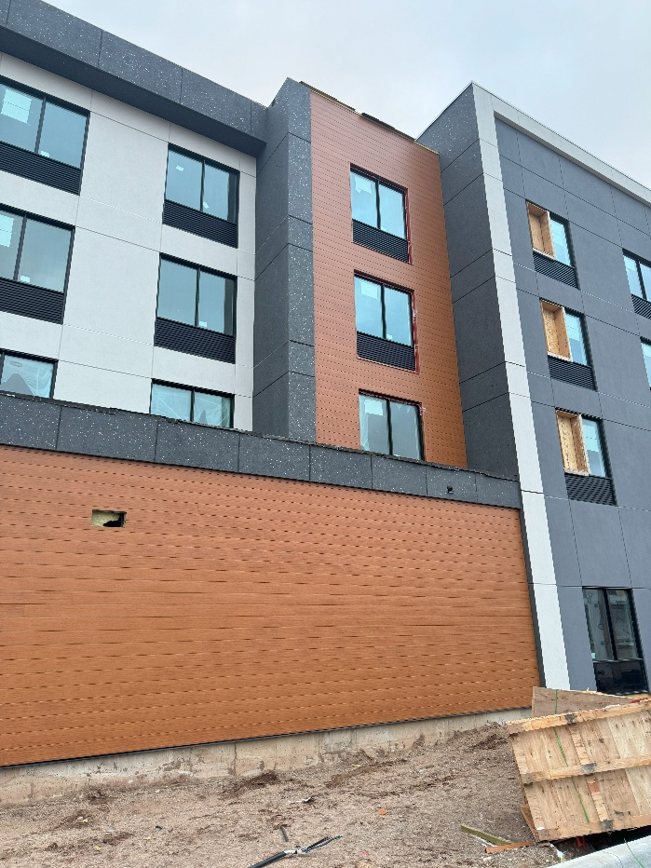
Elevate Your Design with Cedar Renditions®—Premium Style at a more competitive price
Cedar Renditions® combines high-end aesthetics with low-maintenance durability, offering a cost-effective alternative to other aluminum siding products. (Learn More / Expand)
Designed for exceptional performance without the premium price tag, it provides the warmth of stained wood with the resilience of aluminum—enhancing exteriors as a striking focal point or seamless accent for cost-conscious projects

- 1 CEDAR RENDITION PAGE (EXPANDED)
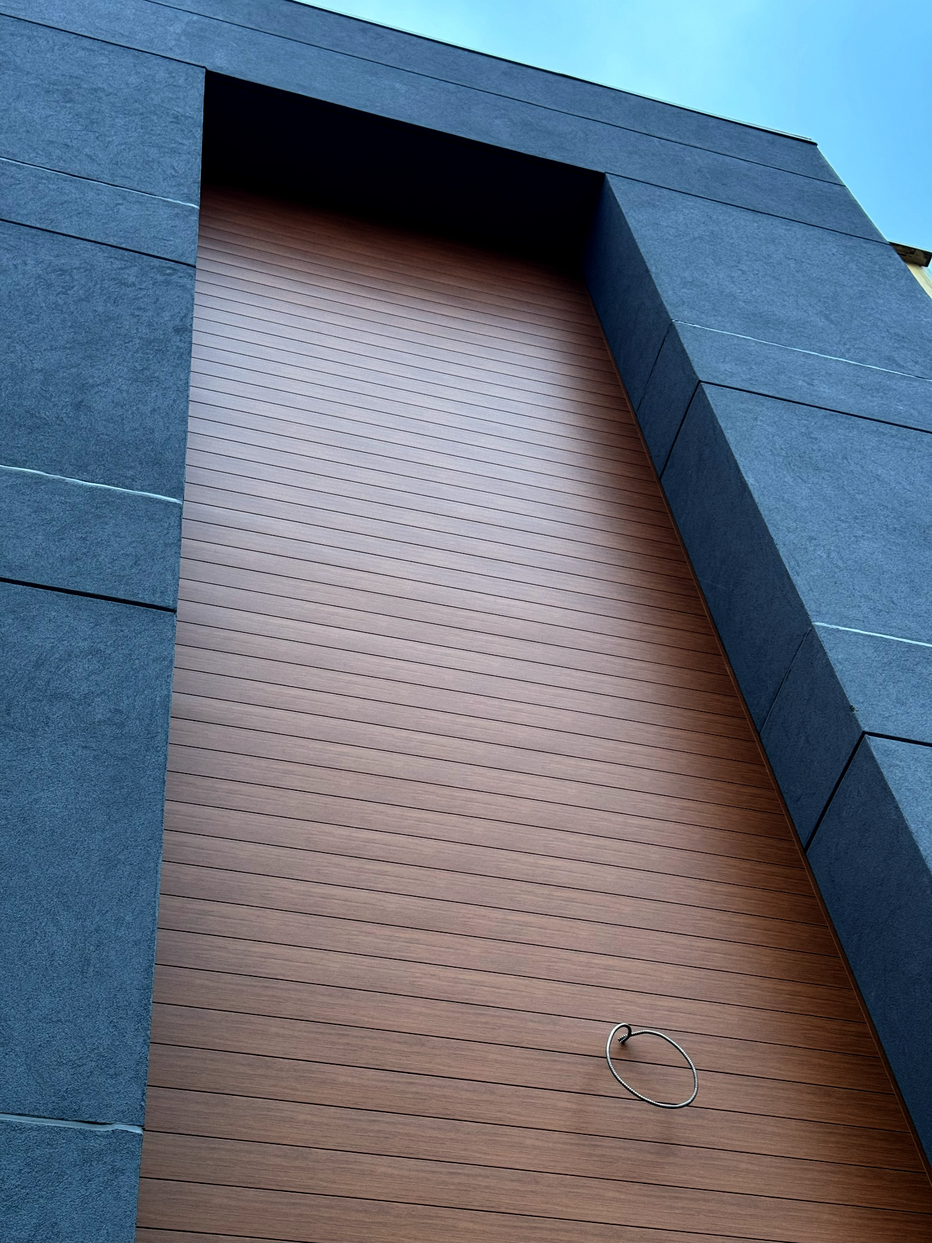
Expanded … Elevate Your Design with Cedar Renditions®—Premium Style at a more competitive price
Cedar Renditions® combines high-end aesthetics with low-maintenance durability, offering a cost-effective alternative to other aluminum siding products.
Designed for exceptional performance without the premium price tag, it provides the warmth of stained wood with the resilience of aluminum—enhancing exteriors as a striking focal point or seamless accent for cost-conscious projects

Key Features & Benefits:
- More affordable than other aluminum siding options
- Realistic woodgrain appearance
- Made from 99% recycled content
- Virtually maintenance-free
- Moisture-resistant and non-combustible
- Easy installation
- LEED compliant and 100% recyclable
- 25-year prorated limited warranty
- Engineered to withstand winds up to 200 mph
- PVDF topcoat for superior paint durability
- Overlapping horizontal panel design for extended lengths
Speak with an Expert
Get personalized advice and expert guidance to achieve your project goals with confidence.

Profile Options
4” & 6” Siding, 6” Soffit, V-Groove Soffit, Board & Batten, D4 & D4D Traditional Siding, Trims & Accessories
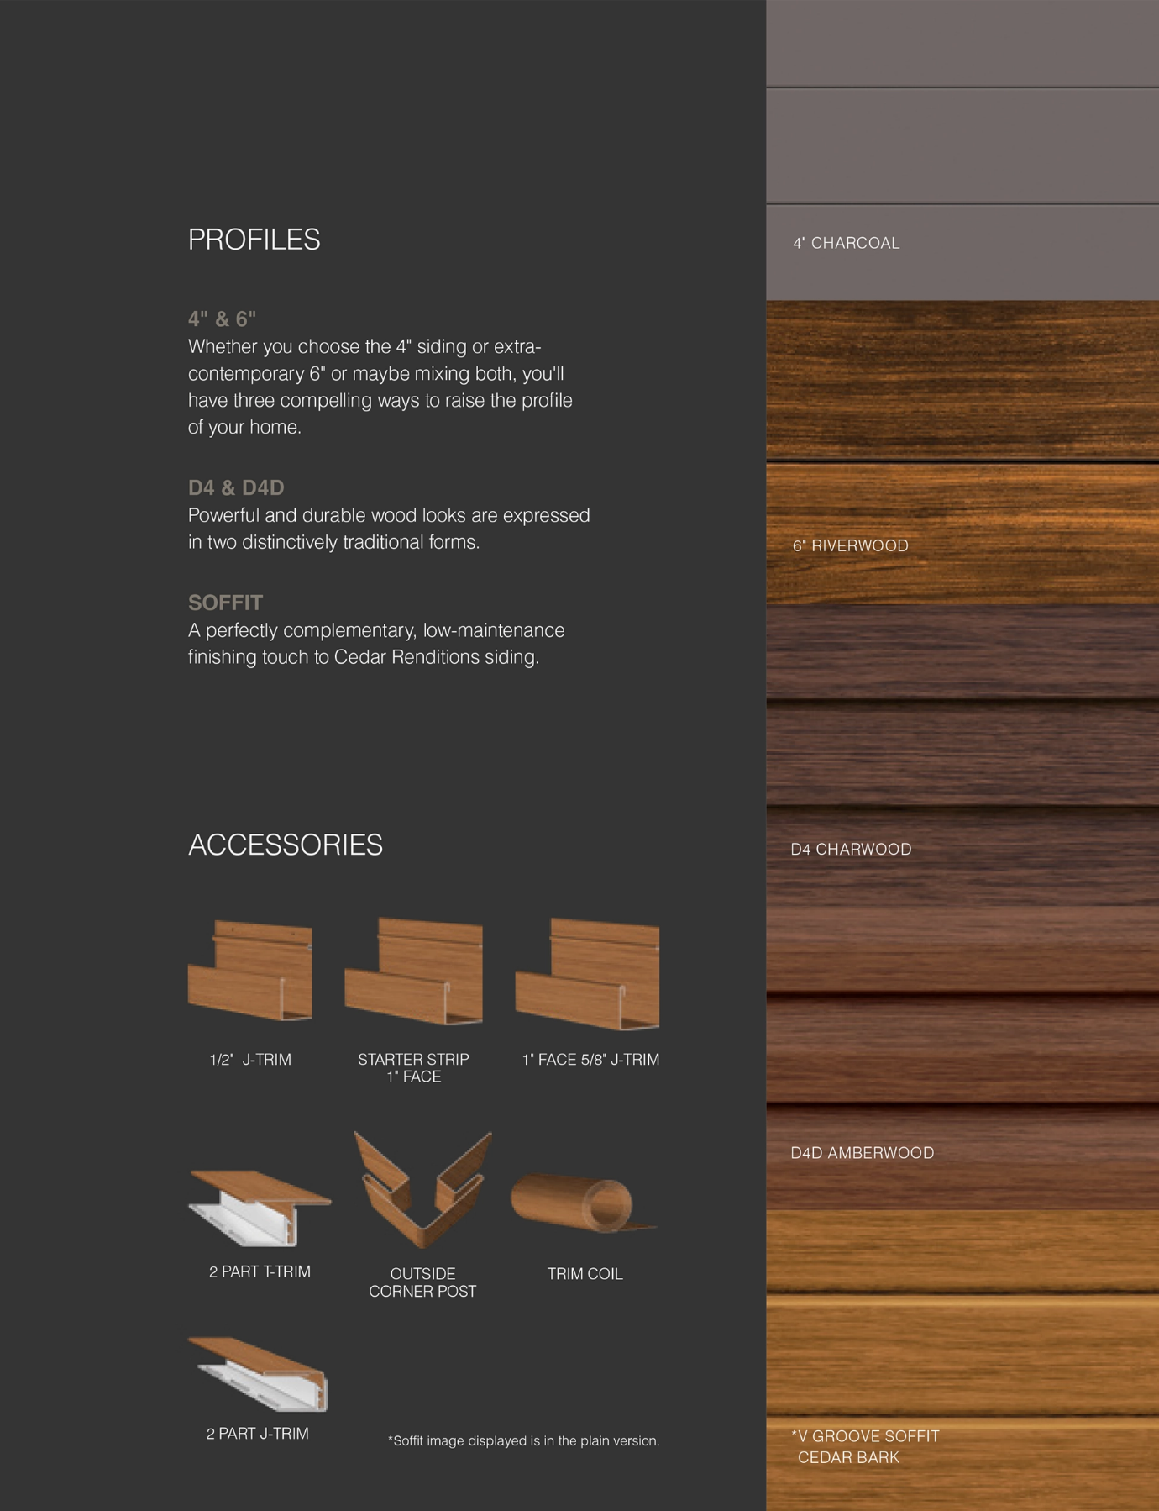
Premium Colors

NATURAL DEPTH.

AUTHENTIC WOOD

APPEAL
Our premium woodgrain finishes feature a blend of dark, medium, and light tones across panels. When installed together, they create a rich, natural variation that closely mimics the depth and character of real stained wood.
